# **Work Breakdown Agreement**

|  |  |  |
| --- | --- | --- |
| Item | Person in charge | Complete by |
| **(I) Class diagrams**  **(II) Interaction diagrams and**  **(III) Design rationale based on functionalities we are in charge of individually:** |  |  |
| BreedingAction & Lay Egg  Follow behaviour - mate  Egg (for laying eggs and buying egg from vending machine)  Baby dino  Stegosaur bush killing | Joanne | 20 April 2021 |
| Hunger & Feeding  Follow item (Fruits and Corpse )  AttackAction (Allosaur / Player attacks Stegosaur - implemented in Stegosaur)  Death (Corpse)  Unconsciousness  Allosaur corpse feeding | Jonathan | 20 April 2021 |
| Player - anything about how player can interact with other actors/ items  BuyAction  AttackAction using LaserGun  PlayerFeedAction  VendingMachine  Fruit, Bush, Tree, Dirt  Probability | Nelly | 20 April 2021 |

Signed by:

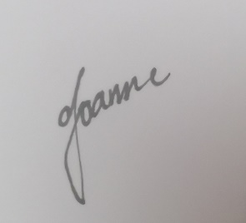

I accept this WBA.

(Joanne Ang Soo Yin)

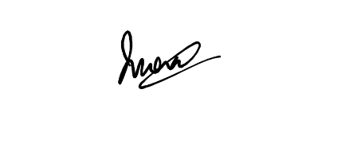

I accept this WBA.

(Jonathan Wong Leong Shan)

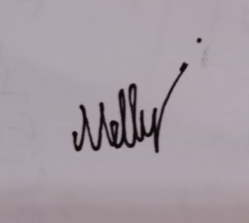

I accept this WBA.

(Nelly Tay Yee Ting)